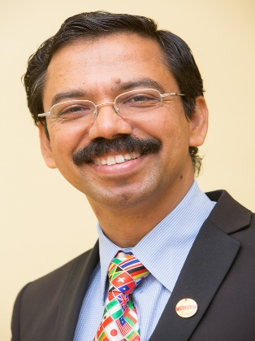**BE SELF SUFFICIENT!**

***“The growth and development of people is the highest calling of leadership” –* Harvey S. Firestone**

It gives lot of happiness to see Division F serving member clubs through innovative ways. Since the inception of Division F, a continuous growth is very much visible. The secret of success is in reinforcing the fundamentals. By consistently instilling the principles of Toastmasters in new members, each club can sustain on a long run. A successful club, new or old, is unique. The qualities that make the club unique, can build pride in the club. By active participation in each and every club activity, including the annual speech contest participation, members can raise to excellence. The members, by utilizing the Toastmasters Education Program to the fullest for achieving their goals, creates a unique atmosphere in the club – an atmosphere filled with positive energy. It is this positive vibe and supporting attitude that attracts new members and make them feel that they are at the right place to make their dream come true. The real growth happens due to those unique features of the club.

Division and Area have the wonderful opportunity of serving the member clubs in developing the right atmosphere and encouraging them by facilitating the team spirit among them. The aim shall be to make each club self sufficient. A club must become independent of its particular leaders and shall thrive on the fundamentals. Each club has adequate leadership reserves, an integral understanding of Toastmasters principles and a drive for excellence. Wishing Division F continued encouragement to its clubs to utilize the resources effectively and to stand firm on their own feet.

***“If you advance confidently in the direction of your dreams, and endeavor to live the life that you have imagined, you will meet with a success unexpected in common hours.”* - Henry David Thoreau**

**Sunil Kottarathil, DTM**  
**District Director, District 105**

Toastmasters International,  
Where Leaders Are Made  
+971-56-6161484  
Skype : sunil-dk  
[www.toastmasters.org](http://www.toastmasters.org/)

[www.district105.org](http://www.district105.org/)

<https://www.facebook.com/groups/d105toastmasters/>

